**# AWS cert developer 2019**

**Lambda**

* Lambda by default works within the default VPC
* Provide Security Group, and Subnet ID to access other resources within the VPC
* Use SMP (system managed parameter) to store and access secret credentials
* Billed for execution time, and memory
* Supports access to Universal resource. e.g. move S3 from one region to another
* Default timeout is 3 seconds, range is 1 – 900 secs
* The more memory allocated to Lambda, the longer CPU time for allocation. Range is 128 MB – 3 GB, in 64 MB increments
* Ephemeral storage is 512 MB
* Role execution policy defines what API action to use like rds:createDbInstance. It does NOT define the AWS resource to use
* Max concurrent batch size for SQS ReceiveMessage is 10 msgs
* For aync execution, set -invocation-type Event during aws lambda invoke --function

**Lambda@Edge CloudFront triggers**

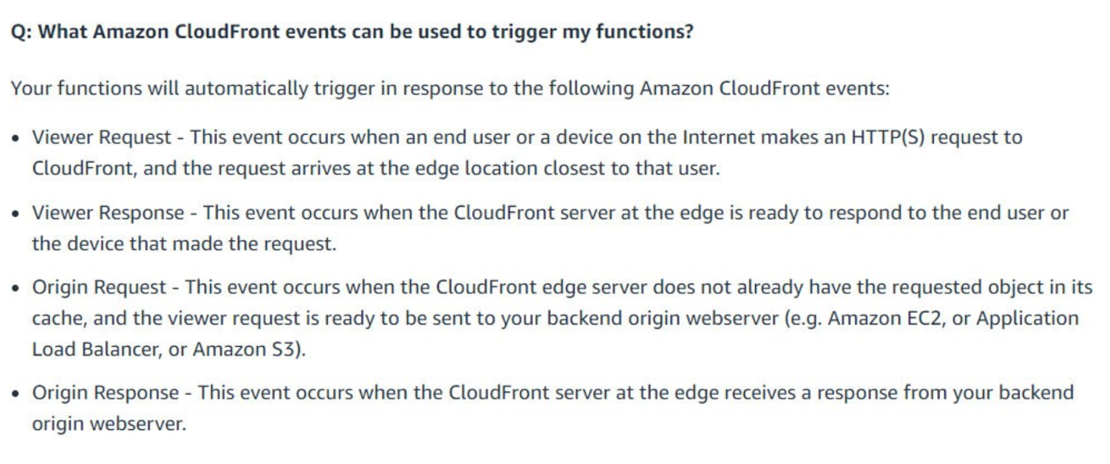

**Configuration Specs**

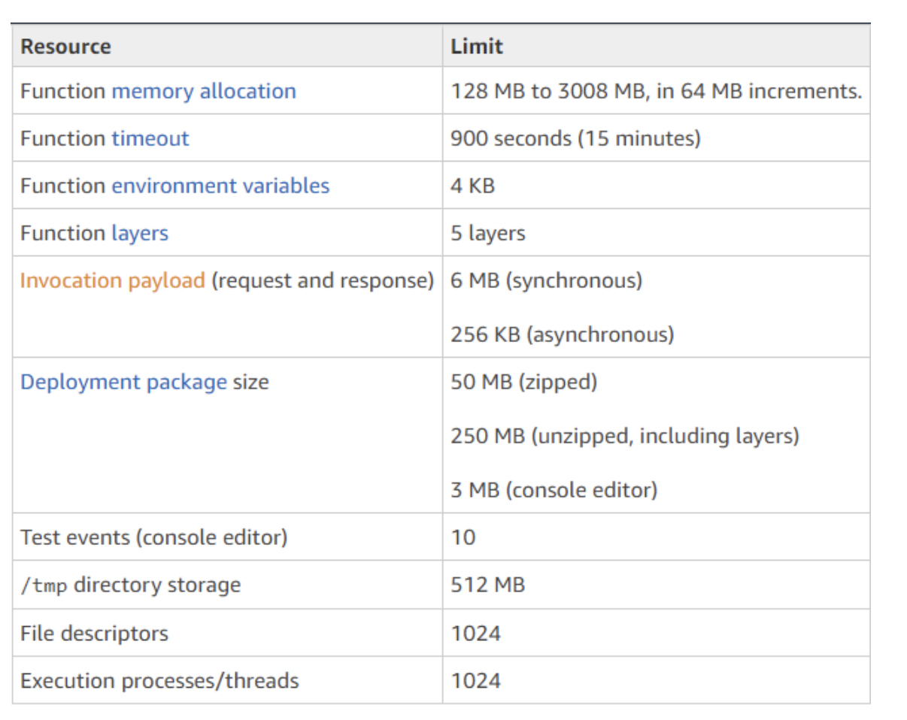

**Dynamo DB**

* At most 5 local secondary indices can be created per table, AWS charges you based on the number of tables created
* When creating multiple tables with secondary indices, it will throw ‘ProvisionThroughputLimitExceed’ if you do not wait for the first table to be created
* Optimistic concurrency control
* Strongly consistent vs eventual consistent, default is eventual consistent
* 1 Read is 4KB for strongly consistent, and 2KB for eventual consistent. 1 Write is 1 KB
* Access is controlled by IAM
* dynamodb:LeadingKey only gives user access to partition matching their User ID
* ProjectionExpression is used to refine the search results
* Scan is more expensive than Query, it scans the entire table
* Query performs on the primary key and return by the Sort Key in asc order
* DAX for read-intensive caching, supports only write-through caching right now. and optimized for DynamoDB. ElasticCache can also be used.
* Exponential back-off is useful when the DB experiences ProvisionedOutputExceed exceptions
* Also good choice for storing session data for a scalable and highly distributed workload
* DynamoDB Streaming for streaming real-time changes made to the table of choice
* Combined Name & Value attributes must be in the confine of 400 KB

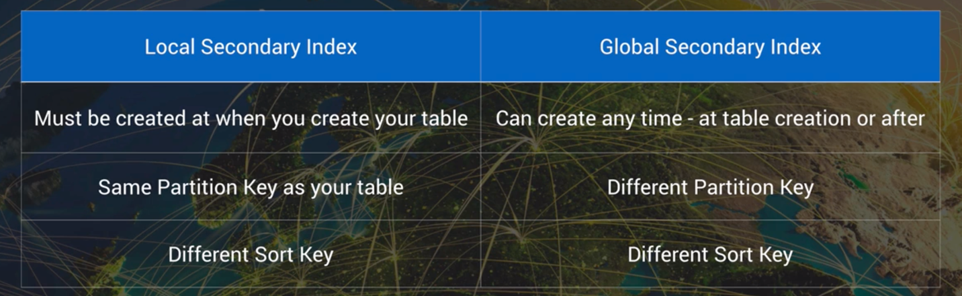

**SNS**

* Topic can be subscribed/unsubscribed by following instructions provided in the email
* If a topic does not work as intended, always inspect event source, subscriber and subscriber functionality. For instance, an SNS topic is triggered by CloudWatch alarm which in turn triggers a Lambda to send emails.

**CodeDeploy**

* Supports Canary (2 increments) / All in once / Linear (% shift increments) deployments for Lambda
* appSpec.yml specifies version number to be deployed into Lamda or EC2

**CodeCommit**

* AWS version control based on Git

**CodeBuild**

* Config allows you to specify location of source code, output of the build

**ECS**

* PortMapping config at the cluster Task level to map a container port to external port on the host

**ECR**

* aws ecr get-login to get a token upon authentication
* docker build / push, etc to pull the docker image from the ECR

**CloudFormation**

* Resources section is the only mandate required in a template to specify which AWS resources to use
* Parameters allow user-inputs to the resources section
* Intrinsic function is executed during run-time and can be written in resource properties, metadata attribute, and update policy attributes. E.g. Fn:FindMap
* Transform references other AWS services
* Nested Stack can be used to refer another cft
* Outputs section is used to output the arn of the AWS resource created

**CloudTrail**

* Audit aws API calls like who provisioned EC2 instance
* Applies to all regions
* Logs are encrypted by default using SSE-S3
* Use CLI to exclude collecting logs from unwanted regions

**CloudWatch**

* Default metric includes Network / CPU / Disk health, metric is sent every 5 mins.
* Memory is a customized metric

**Cognito**

* User Pool manages user sign-up
* Identity Pool manages temporary credential with federated identieis
* In Advanced security section, you can enable Compromise Credential detection
* Cognito Sync syncs data seamlessly across user devices
* Can use SAML Integration with Active Directory

**API Gateway**

* Use with Cognito / Lamba authorizer to control user access
* Caching is configured in the Stage config setting
* Control throttle by API Keys
* SOAP is pass-through
* Capable of import existing APIs via OpenAPI 2.0/3.0, Swagger
* 429 error code indicates throttle limit breached
* Access Log
* Stage can override top level throttle

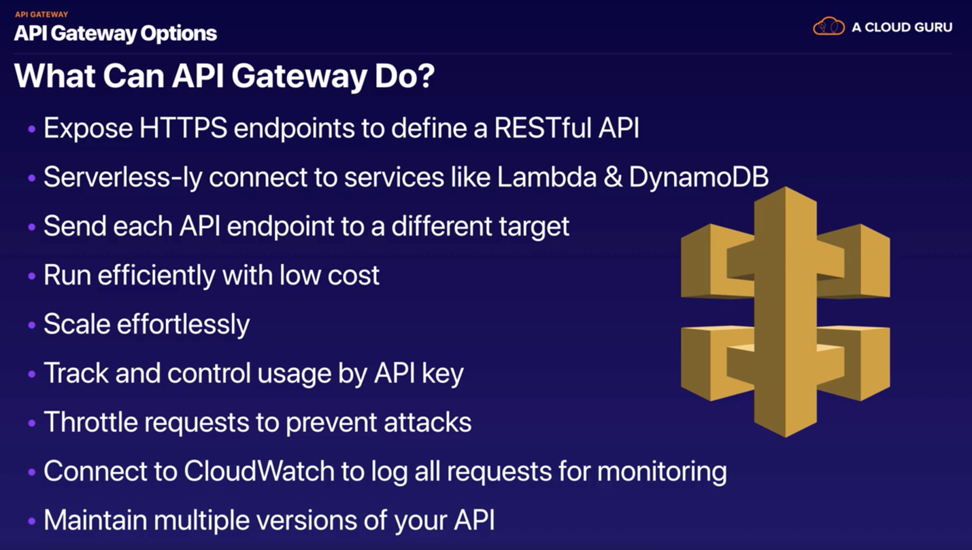

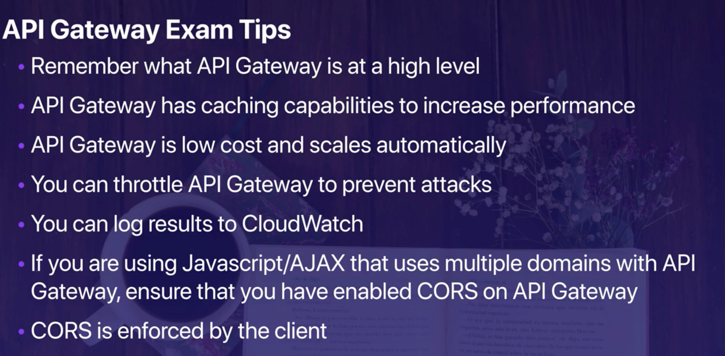

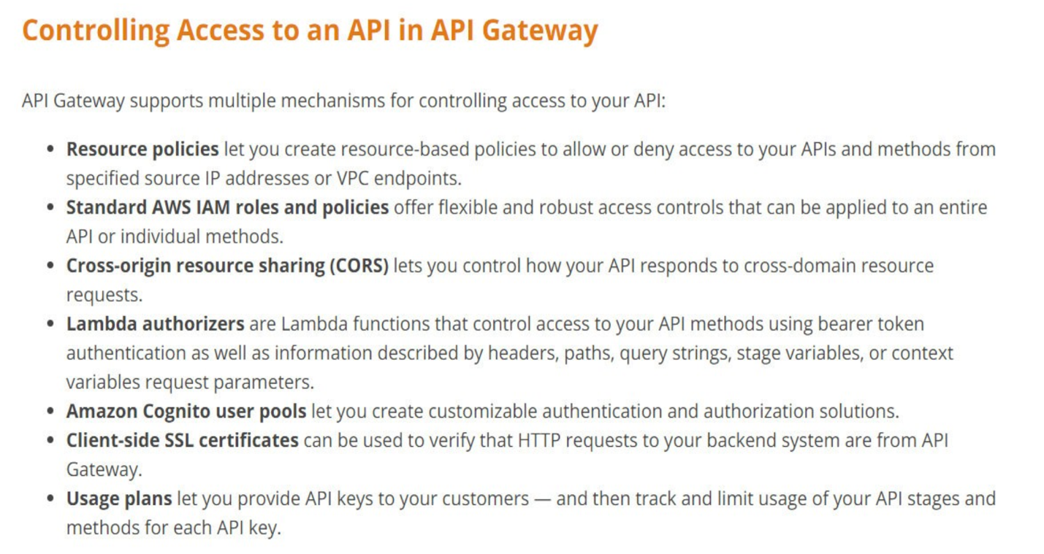

**S3**

* Default managed encryption (SSE-S3) is similar to KMS mechanism involving a master / envelop key
* Default number of buckets is 100 per account, can request aws to extend the limit to a max of 1000 buckets
* Object size is 0 – 5TB, a single PUT can support upload up to 5 GB, recommend using MultiPart upload for >= 100 MB PUTs
* Read after write for PUT of new objects
* Eventual consistency for POST/PUT of existing objects
* CORS / Bucket policy / ACL
* Transfer Acceleration leverages edge location for buckets far from end-users
* S3 Buckets can be used to store Access Logs for all requests made to S3 bucket
* Cross-region repliocation requires Versioning enabled
* As of 7/2018, the Read/Write throughput is 5500 / 3500 requests per sec, respectively
* Bucket is limit to 3 – 64 characters, and the first character must be a either number of a lowercase. Upper case is not support, allows “-“ character.

**S3 Glacier**

* Retrieval time: Standard is 3 – 5 hrs, Bulk is 5 – 12 hrs, expediated is 1 – 5 mins

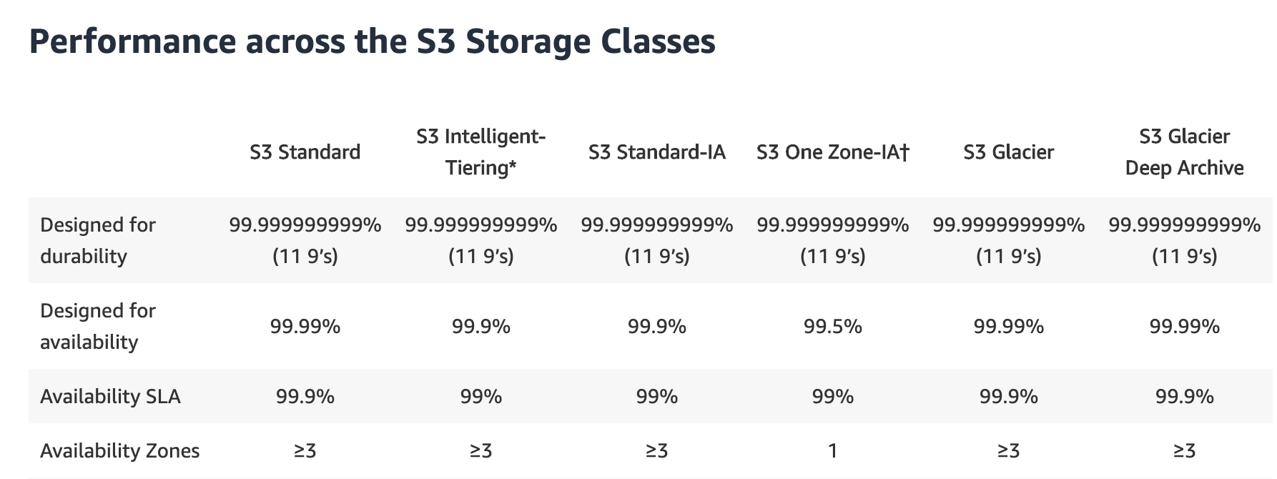

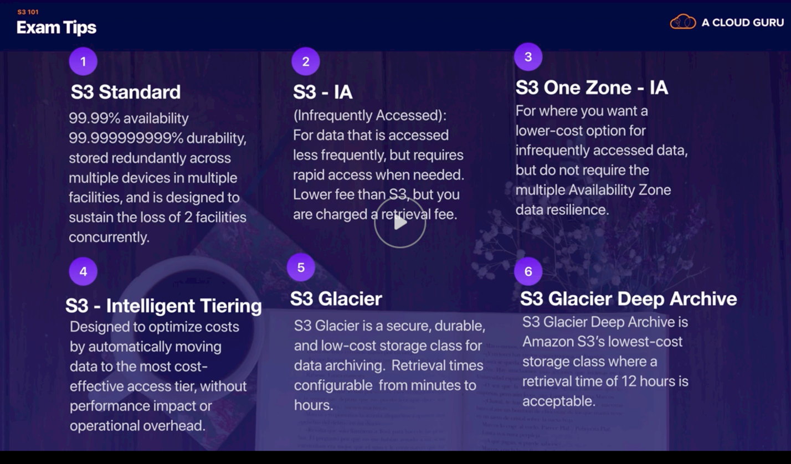

**KMS**

* Customer Master key, can never be exported, and keys are regional
* Multi-tenant hardware
* CLI commands aws kms encrypt / decrypt/ re-encrpty / enable-key-rotation
* CloudHSM is dedicated hardware, and can export CMK
* Master key encrypts envelope key encrypts data

**CloudFront**

* Web vs WTMP distribution
* TTL sets the caching period
* Use signed URL to premium users to access private S3 objects
* Query String Forwarding only supports Web Distribution, and it is used to send users to different version of the site e.g. multi-language

**Auto Scaling Group (ASG)**

* Free, only pay for the underlying resources spin up
* Supports EC2, RDS, DynamoDB
* Can be used in conjunction with ELB / CloudWatch
* Supported modes: Scheduled / Dynamic (target Tracking scaling) / Static

**CLI**

* Pagination to limit number of results
* Query params

**X-Ray**

* Debugging distributed application
* Back by sampling algorithm
* Metadata captures key-value pairs of any type that are not searchable
* You need to implement x-ray SDK into your code
* Supports aws service ELB / Lambda / API Gateway / E Beanstalk / EC2
* Supports frameworks in Java / Ruby / Go / NodeJS/ .NET

**SQS**

* Default visibility timeout is 30 sec, range is 0 sec – 12 hrs
* Standard vs FIFO queue
* Long polling can be achieved by settings WaitTimePeriod in the ReceiveMessage request to be between 1 – 20 sec
* Use with SNS to create a “fanout” scenario for async process
* Max retention period for a message is 14 days, message size is up to 256 KB. Can use Java SDK to increase this to be 2 GB
* First AWS service offered
* Scenario to use dead-letter queue / delay-queue on the [SQS FAQs](https://aws.amazon.com/sqs/faqs/)
* VisibilityTimeOut, msg will be made invisible by another worker, if a worker has already picked it up
* DelaySeconds, delay the message intentionally, typically used for reducing S3 eventual consistency error
* WaitTimes, allows the worker to remain in the queue for the time being before closing the connection

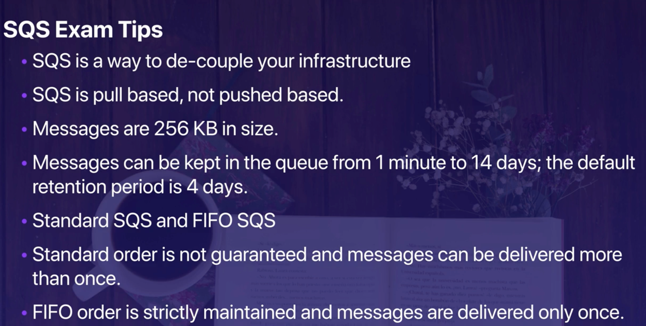

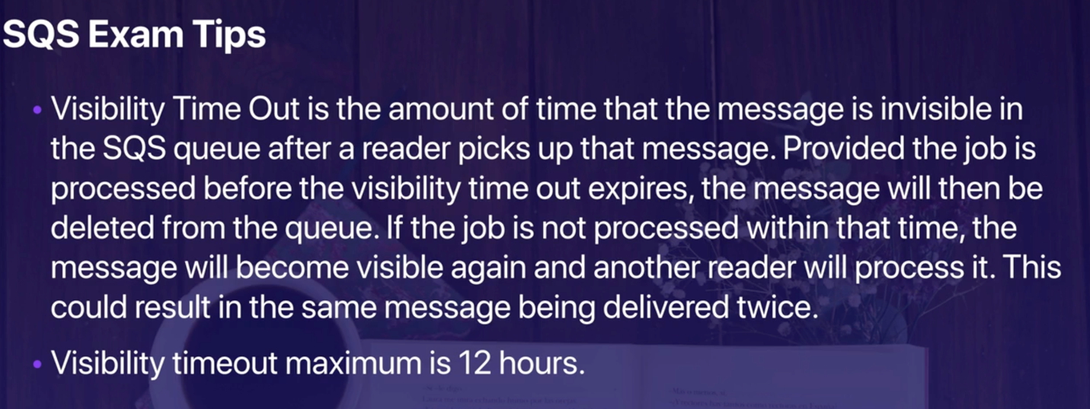

**Kinesis**

* Kinesis Streams stores data in shards, more customizable
  + Video mode
  + Data mode
  + 24 hour retention for 7 days
* Kinesis Firehose
  + less management than Streams
  + No data storage
* Kinesis Analytics
  + Analytics service integratable with Streams of Firehose
* Number of EC2 cannot exceed the total number of shards. But the EC2 can read from multiple shards simultaneously

**Step Function**

* Use to orchestrate serverless Lambdas
* Have different states between each step

**Simple Work Flow Service (SWF)**

* Workflow orchestration for both manual and automated tasks

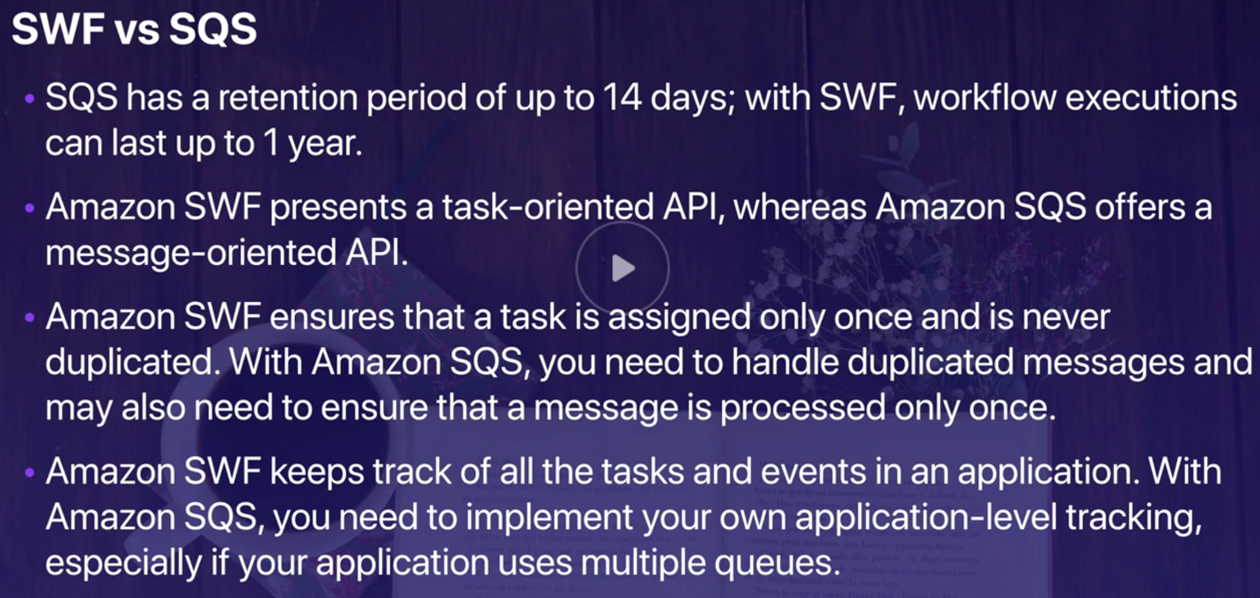

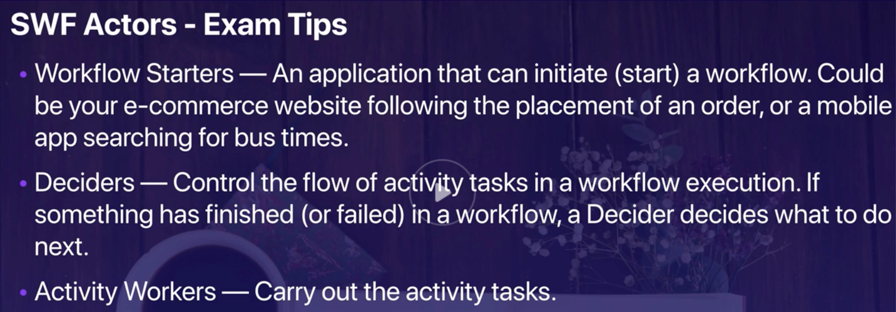

**IAM**

* Universal, not Region specific
* MFA recommended for 2-layer authentication
* Use user account instead of Root
* JSON policy doc
* AWS managed vs Custom vs Inline policy
* New Users have no permission when first created
* Cross-account IAM Role is ideal for auditing

**EC2**

* On-demand / Spot / Reserved / Dedicated
* Billed per second On-demand / Spot / Reserved, Amazon Linux AMI and Ubuntu AMI
* Storage see EBS section below

**ElasticCache**

* Redis (supports more complex operation like sorting)
* Memcached (simple)
* Great for storing session data for distributed workload, i.e. no StickySession!

**Load Balancers**

* ALB
  + Can do PATH based routing
* NLB
  + Does not support Custom Security policy
  + Requires Protocol & Cipher
* CLB
  + Classic load balancer, not recommended
* 504 error means Web, or DB application is timing out
* iPV4, x-forward-header to get user IP

**Elastic Beanstalk**

* Deployment model
  + All at Once - only suitable for dev, all instances will be shut down during deployment
  + Rolling update – has performance impact, old instances will be shut down during deployment as new ones are coming online and then switch. Roll-back requires deployment of the older code.
  + Rolling with additional batch - no downtime, but roll-back requires deployment of the older code.
  + Immutable - preferred for mission critical system, no downtime.
* .ebextensions must be place at the root folder, config can be in either yml / json with .config file extension
* Recommened to launch RDS outside of the env, and save the connection string in S3.

**RDS**

* Multi-AZ for DR, not performance optimization. This can help with certain RDS products to minimize impact of DB backup.
* EBS is recommended to host RDS for development ???
* In Prod, recommends hosting RDS separately, and then attach sg and connection string in EBS volume of the EC2 instance ???
* Read replica can be used to help out load with read-heavy traffic
* Encryption can be done at the RDS creation level, certain EBS volumes do not support encryption

**Redshift**

* Enhanced VPC routing needs to be enabled to access resources within the VPC without going over the internet

**Config**

-Inventory of aws resources, need to be enable before using

**CodePipeline**

* appSpec file, must be placed at the root directory
* Lambda - yml / json format config, versions / resources / hooks (beforeAllowTraffice / afterAllowTraffic) tags
* EC2 and on-premise - only yml / os / files / hooks. See run-order below

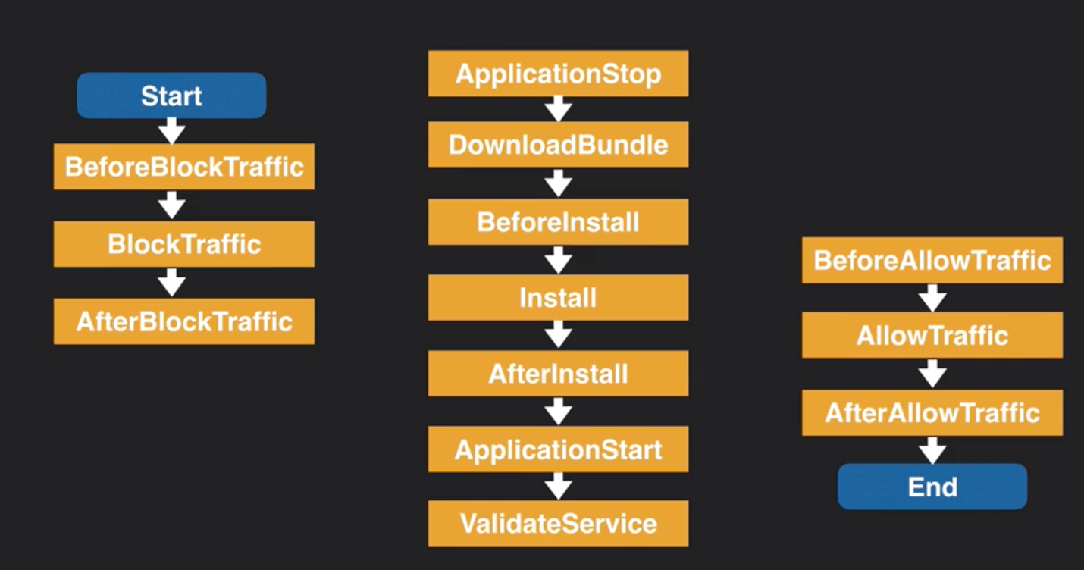

**SAM** (serverless application model)

* Extension of CloudFormation specific for serverless Lambda
* Common CLI command - sam package, and sam deploy

**Took the exam in July-2019, with a passing ~800/1000 score, share some exam impressions:**

* Heavy focus on Lambda from a hands-on development perspective
* Know CloudFormation template
* There were a few surprising questions that I never saw with reputable online training classes
  + ECS Port Mapping
  + Elastic Beanstalk deployment
  + Kinesis streaming applications

**# AWS solutions architect – associate 2019 – more focus on Networking / Scalability / High availability than the Developer test**

**Billing**

**-**when Consolidated billing is enabled, Reserved Instances (RI) are automatically shared in the same AZ

- RI coverage report can show the utilization of these instances

**Athena**

* S3 search and analytics
* Helpful for analysing Billing costs

**VPC**

* Custom VPC comes with a default route table (public access) / NACL / SG
* SG cannot span VPCs
* SG is stateful, NACL is stateless
* VPN connection
* One subnet cannot span AZs
* CIDR block calculation e.g. usable IP range 152.0.0.0/27 -> 32 – 27 = 5, 2^5 = 32 -5 = 27 . Remember 5 IPs are reserved by AWS (first 4 and last 1)
* Free, only pay for other resources contain within
* Security Groups only has ALLOW rules, and can be attached to instance
* NACL allows both ALLOW and DENY rules, and works at the Subnet level
* NAT gateway also requires IGW for connectivity to the Internet

**Migration Tools**

* Migrate stuff??

**Virtualization**

* VM Import / Export
* Hardware virtualization / Physical virtualization

**Storage Gateway**

* File Gateway (NFS) / Volume Gateway (isCSI)
  + stored volume, store locally and async backup to AWS
  + cache volume, cache most frequently used data
* Virtual Tape Library
  + Works with popular backup apps like NetBackup / Backup Exec / Veeam

**Route53**

* A / CNAME record – CNAME cannot be used on root domain
* Routing policies
  + Simple – simple route to one server always
  + Multi-value – multiple servers
  + Weighted – can assign weight, super helpful for B/G deployment
  + Geolocation – direct traffic based on geography location
  + Geoproximity – direct traffic to the closest edge location
  + Failover – send traffic to secondary location in case primary is down

|  |  |  |
| --- | --- | --- |
| **Target** | **A or CNAME** | **Alias** |
| **API gateway** | **A** | **Y** |
| **CloudFront** | **A** | **Y** |
| **EC2** | **A** | **N** |
| **Elastic Beanstalk** | **CNAME** | **N** |
| **ELB** | **A** | **Y** |
| **RDS** | **CNAME** | **N** |
| **S3 Website** | **A** | **Y** |
| **VPC Endpoints** | **A** | **Y** |

**Trusted Advisor**

* Helps you better utilize AWS resources

**Polly**

* Text parsing service

**VPC Endpoints**

* Gateway endpoints only supported for S3 and DynamoDB
* Interface endpoints support a whole bunch of other services

**Block Chain**

* Sample ARN: ResourceID.MembersID.NetworkID.some_block_chain_arn

**KMS**

**AMI**

**-**AWS does not copy user-defined tags / Launch permission / Bucket permission

**EBS**

* General SSD / HDD
* Know their application based on throughput and storage requirement
* EBS Snapshots, or AMIs are stored in S3 buckets
* EBS vol by default are replicated within AZ

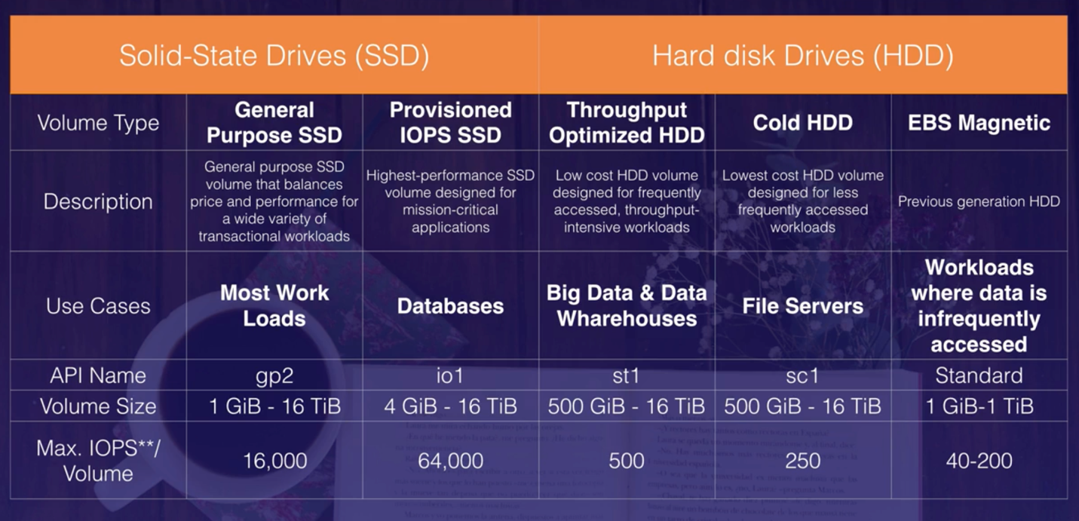

**EC2**

* EFS – elastic, scalable
* Read-after write consistency
* Placement groups

- Cluster placement – single AZ, low latency, certain instances are qualified for this

- Spread placement – distinct hardware, max number of instance supported is 7 per AZ

- Partitioned – distinct hardware, only available via CLI

- aws limits total # of instance to 20 per region by default, this can be raised

**EFS**

**-**Performance mode, deals with latency

-Throughput mode, deals with aggregate throughput

-Only one mount target is required per AZ

-Supports cross account, VPC peering

**AWS SSO**

- max Custom Permission set for session is 12 hours

- context aware 2-step with email verification

- 2-way trust

**VPN**

**-** Software approach, install VPN server

- AWS recommended hardware approach – involves a Customer Gateway (with public IP), Virtual Private Gateway, Hardware VPN

- Set up Routes between Customer Gateway & VPG

- only 1 VPG can be attached to a VPC

- Customer Gateway can be a single point of failure, setup multiple instances for redundancy

- Customer Gateway supports both Static and Dynamic Routing based on BPG ASN

- Traffic encrypted by IPSec over the Internet

There are a number of ways to set up a VPN. Based on the options provided, AWS have a standard solution that makes use of a VPC with; a private subnet, Hardware VPN Access, a VPG, and an on-premise Customer Gateway.

**Direct Connect**

**-** traffic does not get routed over the public Internet

-look out for overlapping CIDR blocks in the VPC connected via Direct Connect

**VPC Peering**

-Peer between VPCs to share resources

-Not transitive

- Can be applied to the entire VPC or Subnet or a Instance

- Cross-accoung support

**Security Services**

-Machie, use machine learning to discover sensitive / vulnuerability in data stored in S3, AWS is looking to expand this into other data stores

-Inspect, agents can be installed on EC2 to inspect vulnuerability

-Shield, protect against DDOS

-WAF, firewall

-GuardDuty, machine learning base intelligent threat detection to fortify account level security